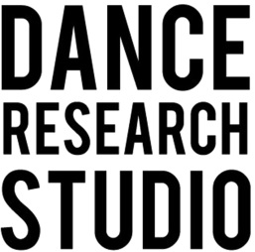
Studio Hire – Booking Form
Please note there is a minimum 2 hour booking for research or rehearsal
What will you need the studio for?

Creative development

Research

Workshop

Class
Other (please specify) _____________________________________________
Style?
_______________________________________________________________
Day and time you would like to hire?
_______________________________________________________________
How many participants will attend? (14 maximum)
_______________________________________________________________
Are you a funded company?
_______________________________________________________________
Contact details:
Name:
Email:
Telephone number:
Website:
Have you booked with DRS before?

Yes No
Please tick if you have read and agree with studio specifications and important notes below

Studio Specifications
- Approximately 10m x 7m with one off center pillar
- Sprung wood dance floor
- Sound System
- Mirrors
- Piano
- Yoga mats, blocks and Pilates Balls available

Important notes
- NO shoes are allowed in the space (unless non-marking flat indoor shoes)
- DRS is not insured for hires under the age of 18
- We are not wheelchair accessible
- The bathroom is at the top of the stairs and clients are welcome to change in it.
- Our maximum capacity (depending on type of activity) is around 14 people

Please be aware that there will be staff working next to the studio, separated by a curtain Tuesdays and Fridays (10:00 am – 2:00 pm).

